**Problem Statement – 2**

**Write a program that prompts the user to input number of calls and calculate the monthly telephone bills as per the following rule:**

● Minimum Rs. 200 for up to 100 calls.

● Plus Rs. 0.60 per call for next 50 calls.

● Plus Rs. 0.50 per call for next 50 calls.

● Plus Rs. 0.40 per call for any call beyond 200 calls.

def calculate_telephone_bill(num_calls):

base_charge = 200 # Minimum charge for up to 100 calls

cost_per_call_1 = 0.60 # Cost for the next 50 calls

cost_per_call_2 = 0.50 # Cost for the next 50 calls

cost_per_call_3 = 0.40 # Cost for any call beyond 200 calls

if num_calls <= 100:

total_cost = base_charge

elif num_calls <= 150:

total_cost = base_charge + (num_calls - 100) * cost_per_call_1

elif num_calls <= 200:

total_cost = base_charge + 50 * cost_per_call_1 + (num_calls - 150) * cost_per_call_2

else:

total_cost = base_charge + 50 * cost_per_call_1 + 50 * cost_per_call_2 + (num_calls - 200) * cost_per_call_3

return total_cost

if __name__ == "__main__":

num_calls = int(input("Enter the number of calls: "))

monthly_bill = calculate_telephone_bill(num_calls)

print("Monthly Telephone Bill: Rs.", monthly_bill)

**Enter the number of calls: 100**

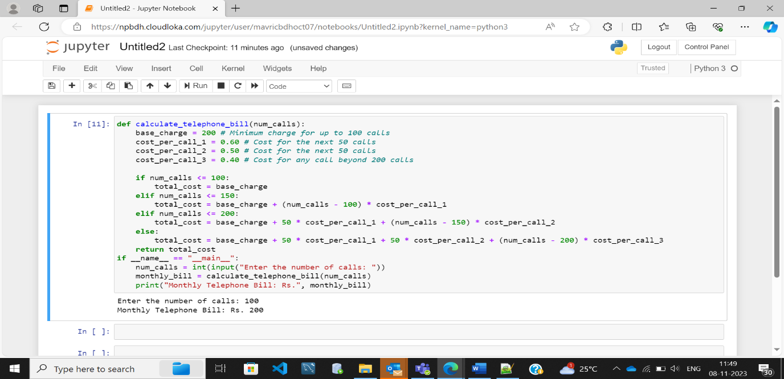

**Enter the number of calls: 150**

**Enter the number of calls: 200**

**Enter the number of calls: 300**

